Project: WAV maker

Author : Kevin Karplus

Actual Code Lines: 73

//It’s not a simulation, but I though the interaction with WAV files could be interesting.

Files: main.c , make_wav.c , make_wav.h

UML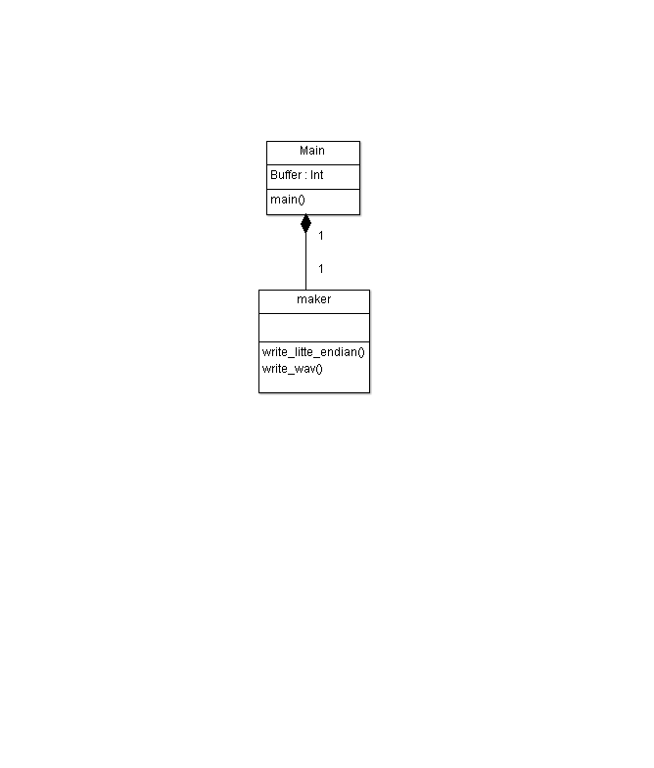

Main.c

#include <stdio.h>

#include <stdlib.h>

/* test_make_wav.c

* Fri Jun 18 17:13:19 PDT 2010 Kevin Karplus

* Test program for the write_wav function in make_wav.c

*/

#include <math.h>

#include "make_wav.h"

#define S_RATE (44100)

#define BUF_SIZE (S_RATE*2) /* 2 second buffer */

int buffer[BUF_SIZE];

int main(int argc, char * argv)

{

int i;

float t;

float amplitude = 32000;

float freq_Hz = 440;

float phase=0;

float freq_radians_per_sample = freq_Hz*2*M_PI/S_RATE;

/* fill buffer with a sine wave */

for (i=0; i<BUF_SIZE; i++)

{

phase += freq_radians_per_sample;

buffer[i] = (int)(amplitude * sin(phase));

}

write_wav("test.wav", BUF_SIZE, buffer, S_RATE);

return 0;

}

Make_wav.c

/* make_wav.c

* Creates a WAV file from an array of ints.

* Output is monophonic, signed 16-bit samples

* copyright

* Fri Jun 18 16:36:23 PDT 2010 Kevin Karplus

* Creative Commons license Attribution-NonCommercial

* http://creativecommons.org/licenses/by-nc/3.0/

*/

#include <stdio.h>

#include <assert.h>

#include "make_wav.h"

void write_little_endian(unsigned int word, int num_bytes, FILE *wav_file)

{

unsigned buf;

while(num_bytes>0)

{ buf = word & 0xff;

fwrite(&buf, 1,1, wav_file);

num_bytes--;

word >>= 8;

}

}

/* information about the WAV file format from

http://ccrma.stanford.edu/courses/422/projects/WaveFormat/

*/

void write_wav(char * filename, unsigned long num_samples, short int * data, int s_rate)

{

FILE* wav_file;

unsigned int sample_rate;

unsigned int num_channels;

unsigned int bytes_per_sample;

unsigned int byte_rate;

unsigned long i; /* counter for samples */

num_channels = 1; /* monoaural */

bytes_per_sample = 2;

if (s_rate<=0) sample_rate = 44100;

else sample_rate = (unsigned int) s_rate;

byte_rate = sample_rate*num_channels*bytes_per_sample;

wav_file = fopen(filename, "w");

assert(wav_file); /* make sure it opened */

/* write RIFF header */

fwrite("RIFF", 1, 4, wav_file);

write_little_endian(36 + bytes_per_sample* num_samples*num_channels, 4, wav_file);

fwrite("WAVE", 1, 4, wav_file);

/* write fmt subchunk */

fwrite("fmt ", 1, 4, wav_file);

write_little_endian(16, 4, wav_file); /* SubChunk1Size is 16 */

write_little_endian(1, 2, wav_file); /* PCM is format 1 */

write_little_endian(num_channels, 2, wav_file);

write_little_endian(sample_rate, 4, wav_file);

write_little_endian(byte_rate, 4, wav_file);

write_little_endian(num_channels*bytes_per_sample, 2, wav_file); /* block align */

write_little_endian(8*bytes_per_sample, 2, wav_file); /* bits/sample */

/* write data subchunk */

fwrite("data", 1, 4, wav_file);

write_little_endian(bytes_per_sample* num_samples*num_channels, 4, wav_file);

for (i=0; i< num_samples; i++)

{ write_little_endian((unsigned int)(data[i]),bytes_per_sample, wav_file);

}

fclose(wav_file);

}

Make_wav.h

/* make_wav.h

* Fri Jun 18 17:06:02 PDT 2010 Kevin Karplus

*/

#ifndef MAKE_WAV_H

#define MAKE_WAV_H

void write_wav(char * filename, unsigned long num_samples, short int * data, int s_rate);

/* open a file named filename, write signed 16-bit values as a

monoaural WAV file at the specified sampling rate

and close the file

*/

#endif